|  |  |
| --- | --- |
| International Forum on AI and Futures of Education 2020 organized by UNESCO  and China – UNESCO IITE  Project report on Result Prediction  Dr. Subhan Allah | Abstract  [Draw your reader in with an engaging abstract. It is typically a short summary of the document. When you’re ready to add your content, just click here and start typing.]  Electronics  [Course title] |

Contents

Chapter 1 : Introduction 3

1.1 About AI 3

1.2 Role of AI in Education 3

1.3 Role of AI in Healthcare 4

1.4 Role of AI in Defense 4

Chapter 2 : 5

Result Prediction 5

2.1. about the Project 5

2.2. Tools used 5

a. Google colab 5

b. Glitch 5

Table of Figures

Figure 1 : AI landscape 3

Figure 2: AI in Education 3

Figure 3 : AI in healthcare 4

Figure 4 : Colab platform 5

Figure 5 : Glitch 5

Code table

Code : 1 - Student class 6

Code : 2 – Using Student class 6

# Chapter 1 : Introduction

## About AI

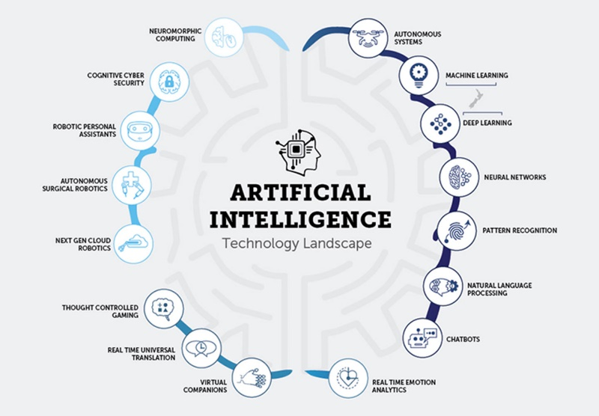Machine learning is field of AI and it rules the world. Artificial intelligence (AI) is intelligence demonstrated by machines, as opposed to natural intelligence displayed by animals including humans. Leading AI textbooks define the field as the study of "intelligent agents": any system that perceives its environment and takes actions that maximize its chance of achieving its goals.[a]

Figure 1 : AI landscape

Some popular accounts use the term "artificial intelligence" to describe machines that mimic "cognitive" functions that humans associate with the human mind, such as "learning" and "problem solving", however, this definition is rejected by major AI researchers.[b]

## Role of AI in Education

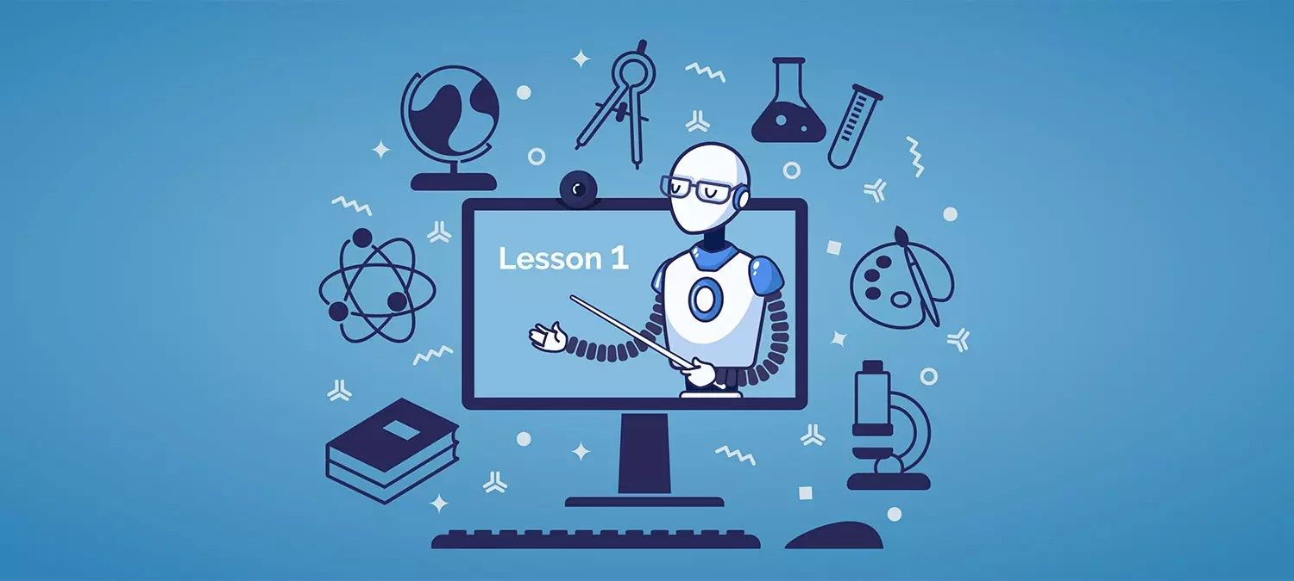AI applications include advanced web search engines (e.g., Google), recommendation systems (used by YouTube, Amazon and Netflix), understanding human speech (such as Siri and Alexa), self-driving cars (e.g., Tesla), automated decision-making and competing at the highest level in strategic game systems (such as chess and Go).[2][citation needed] As machines become increasingly capable, tasks considered to require "intelligence" are often removed from the definition of AI, a phenomenon known as the AI effect.[3] For instance, optical character recognition is frequently excluded from things considered to be AI,[4] having become a routine technology.[5]

Figure 2: AI in Education

## Role of AI in Healthcare

AI applications include advanced web search engines (e.g., Google), recommendation systems (used by YouTube, Amazon and Netflix), understanding human speech (such as Siri and Alexa), self-driving cars (e.g., Tesla), automated decision-making and competing at the highest level in strategic game systems (such as chess and Go).[2][citation needed] As machines become increasingly capable, tasks considered to require "intelligence" are often removed from the definition of AI, a phenomenon known as the AI effect.[3] For instance, optical character recognition is frequently excluded from things considered to be AI,[4] having become a routine technology.[5]

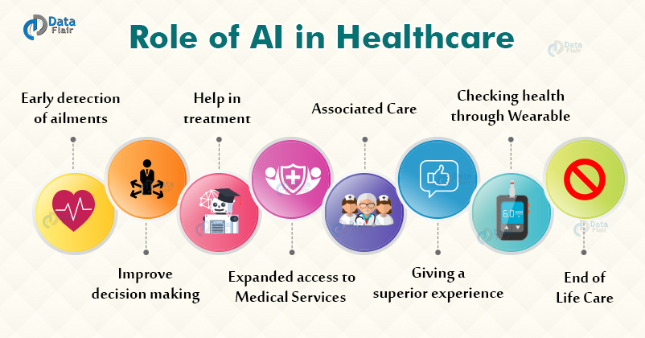

Figure 3 : AI in healthcare

## Role of AI in Defense

Artificial intelligence was founded as an academic discipline in 1956, and in the years since has experienced several waves of optimism,[6][7] followed by disappointment and the loss of funding (known as an "AI winter"),[8][9] followed by new approaches, success and renewed funding.[7][10] AI research has tried and discarded many different approaches since its founding, including simulating the brain, modeling human problem solving, formal logic, large databases of knowledge and imitating animal behavior. In the first decades of the 21st century, highly mathematical statistical machine learning has dominated the field, and this technique has proved highly successful, helping to solve many challenging problems throughout industry and academia

# Chapter 2 :

# Result Prediction

## about the Project

The project will predict the result of students known as an "AI winter"),[8][9] followed by new approaches, success and renewed funding.[7][10] AI research has tried and discarded many different approaches since its founding, including simulating the brain,

modeling human problem solving, formal logic, large databases of knowledge and imitating animal behavior. In the first decades of the 21st century, highly mathematical statistical machine learning has dominated the field, and this technique has proved highly successful, helping to solve many challenging problems throughout industry and academia

## Tools used

Following tools are used to make the project

1. Google colab : this is online cloud platform for ML champs

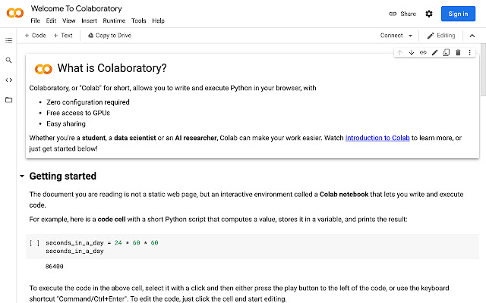

Figure 4 : Colab platform

1. Glitch – online PaaS platform for making the front end



Figure 5 : Glitch

# Chapter 3 :

# Code

## Machine learning code

|  |
| --- |
| class Student:     # defining a onstructor     def __init__(self):       print(' i am in constructor')       self.rollno=-1       self.name  =""       def getName(self, nm):       print(nm)       self.name  = nm     def getRollno (self , rno):       if (rno>0): self.rollno = rno       else :self.rollno = -1  Code : 1 - Student class |
|  |

class Student:

   # defining a constuctor

   def __init__(self):

     print(' i am in constructor')

     self.rollno=-1

     self.name  =""

   def getName(self, nm):

     print(nm)

     self.name  = nm

   def getRollno (self , rno):

     if (rno>0): self.rollno = rno

     else :self.rollno = -1

Code : 2 – Using Student class